# introduction

This template allows using PlantUML directly from MS Word 2010/2013 on Windows (32/64 bit) without need to alter document templates or edit VBA macro's. MS Word Version 2007 may work, but is not tested.

If you cannot see the green boxes in this file, please use the ‘show PlantUML’ button.

## Example

@startuml

participant "Lua plug-in code" as Lua

participant LuaUPnP

participant ZwInt

participant "Z-Wave Controller" as Controller

participant "Z-Wave Device" as Device

Lua->ZwInt : Require zwint

Lua->ZwInt : Register

Lua->LuaUPnP : SendData (Indicator Get)

LuaUPnP-->Controller : Indicator Get

Controller-->LuaUPnP : Ack

Controller->Device : Indicator Get

Controller-->LuaUPnP : Response

LuaUPnP-->Controller : Ack

Device->Controller : Request response

Controller-->LuaUPnP : Request response

LuaUPnP-->Controller : Ack

Device->Controller : Indicator report

Controller->ZwInt : Indicator report

ZwInt-->Lua : Indicator report

ZwInt->LuaUPnP : Indicator report

LuaUPnP-->Controller : Ack (but otherwise ignored)

@enduml

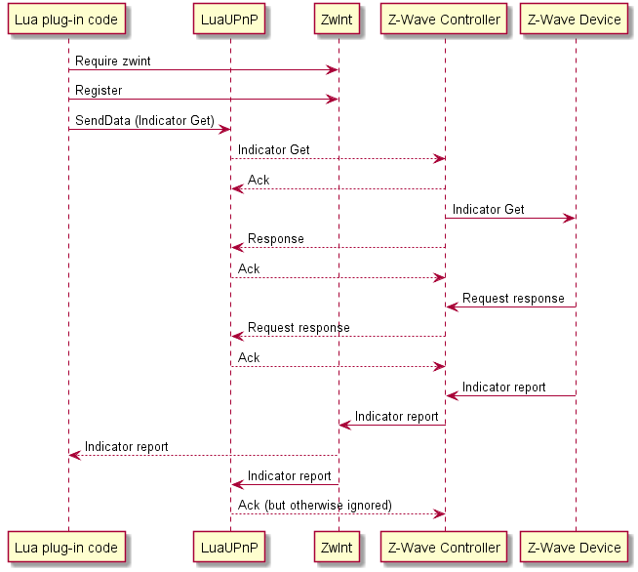

## Installation

First time:

* install this template in Word
  + copy this (docm) file in to %appdata%\Microsoft\Word\STARTUP
* install Plantuml.jar in %appdata%
* install GraphViz
  + <http://www.graphviz.org/Download_windows.php>
    - use installer if you have rights to install applications; this will install graphviz in your program files (x86)
    - use zip for portable installation
      * extract in %appdata%
      * (executable is then in %appdata%\release\bin\dot.exe)
  + if alternative portable installation, please set GRAPHVIZ_DOT  to location of DOT.EXE
* restart Word. You now should have a PlantUML menu!

## Installation

First time:

* install this template in Word
  + copy this (dotm) file in to %appdata%\Microsoft\Word\STARTUP
  + note: .dotm = Word Doc Template (office 2007/2010) with Macro's enabled
* install Plantuml.jar in %appdata%
* install GraphViz
  + <http://www.graphviz.org/Download_windows.php>
    - use installer if you have rights to install applications; this will install graphviz in your program files (x86)
    - use zip for portable installation
      * extract in %appdata%
      * (executable is then in %appdata%\release\bin\dot.exe)
  + if alternative portable installation, please set GRAPHVIZ_DOT  to location of DOT.EXE
* restart Word. You now should have a PlantUML menu!

## Using

Once installed, a special menu (PlantUML) should be available in Word as tab “PlantUML”



P =  : show paragraph marks

Show PlantUML: reveal (green text) of PlantUML image sources (for editing)

Hide PlantUML : hide source, just show generated pictures (before releasing a document for review/UCC)

UML.1 : Generate current diagram (cursor in green PlantUML definition)

UML.* : Generate all (note: this may take seconds up to a minute for 100+ pictures). Press Ctrl-Break to abort.

If you don’t see the toolbar, please check installation instructions. If you load the .dotm file from word (Open file, not double click from explorer) then you should also see the toolbar (or twice if you’ve installed it already).

## About word template

This document contains VBA scripts (based on plantuml007.bas).

Improvements made by Adriaan van den Brand:

* Easy distribution and integration (as a word.docm)
* performance (no new documents created, direct writing of text files)
* fixed issue of images at wrong locations
* better sync with plantuml java (by using ShellandWait module)
* no unnecessary delays
* can be aborted with ctrl-break

Contact:[adriaan.plantuml@gmail.com](mailto:adriaan.plantuml@gmail.com)

I appreciate feedback and improved versions.

@startuml

left to right direction

class WordTemplate {

by Adriaan van den Brand

+PlantUML.bas

+ShellAndWait.bas

---

UML.1()

UML.*()

ShowPlantUML()

HidePlantUML()

}

class PlantUML.jar {

}

class GraphViz.DOT

WordTemplate --|> PlantUML.jar

PlantUML.jar --|> GraphViz.DOT

@enduml

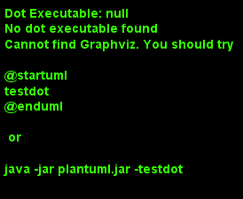

## Background

My name is Adriaan van den Brand and I work as system architect at Philips Innovation Services. I am using plantuml for my technical documents, and wanted to have a straightforward Word integration. This is primarily for my own work, and I gladly share it with the community. The code is not my finest (minimal changes from original vba scripts) but it seems to do the trick. If you have improvements, please contact me.

## Notes for version 2.6/2.7/2.8/2.9/3.0

* Version 3.0
  + added ftp mode (advanced use, high performance)
  + improved uml.1
  + added long help text with toolbar
  + to use ftp mode (experimental!)
    - enable in preferences



ensure that plantuml is started in ftp mode (java -jar plantuml.jar -ftp)

currently only works for png mode.

see <http://plantuml.sourceforge.net/ftp.html>

* + fixed visibility issue images (introduced in 2.9)
* Version 2.9
  + auto-scale-down to fit page
  + copy/paste compatibility (hidden text is not copy/paste compatible; changed style handling)
  + 64 bit compatibility (thanks to Andreas Brusinsky, Gil Fuchs, Ren Vleer, who hinted on the PtrSafe keyword. I cannot try it on a 32bit office. )
* added @rescale keyword (see 1.8)
* better support for non-English Office versions (reference to ‘normal’ style is done by magic number instead of name)
* use of UTF-8 instead of ascii. This may help people using non-ascii characters, but it will cause problems with MS Word autoformatting. Consider disabling autoformat (quotes need to be straight for plantuml to work)
* Version 2.7: added preferences button and support for EPS vector graphics (better print quality)  
  Note: preferences are stored in registry under hkeycurrentuser\PlantUML
* added authors and fixed text in toolbar for UML.1
* version 2.8: added includepath

Future features :

* more help for the visually impaired

## Known issues

* When is at the end of a table cell, no image is inserted (at least, no image becomes visible). This seems related to the odd table structures in word. There is a next paragraph, yet it is not visible.
* If an error occurs inserting the picture, the macro’s may assume that  is at the end of the document. So if pictures appear at the end of the document, please check that there is a line after each 
* autoformat (automatic bullets/arrows) are not compatible with plantuml. Use toolbar button for quick access. Note that this will not change the autoformat as you type (--> into →).
* formatting plantuml can be improved
* add-ins from previous version are still created (so 2 methods of invoking plantuml after first Uml.* run)
* mismatched startuml/enduml pairs will cause pictures to be inserted in the wrong place
* ftp mode only works for png files

## Rescale

Plantuml supports a scale keyword. This will scale the generated png file. However, when downscaling, text may become coarse. To solve this, the @rescale (use in plantuml comment!) provides a post-processing scale. Scale is supported only as a float number between 0.1 and 10

Example: 2.4 Components (and @rescale)

Note: should not be needed often from 2.9 onwards (automatic scale to page)

## Version info plantUML

The following picture should be updated when you select PlantUML (menu) UML.1 or UML.*

@startuml

version

@enduml

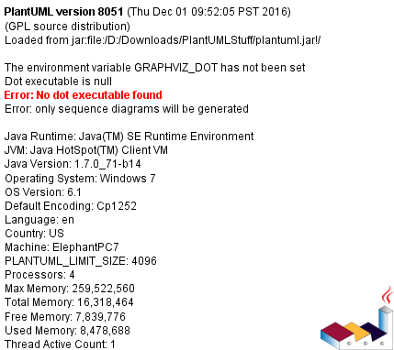

## Check for updates

@startuml

checkversion

@enduml



## License information

For license information of PlantUML, please check out <http://plantuml.sourceforge.net/>

The code below will generate a copyright image (if correctly installed)

@startuml

license

@enduml

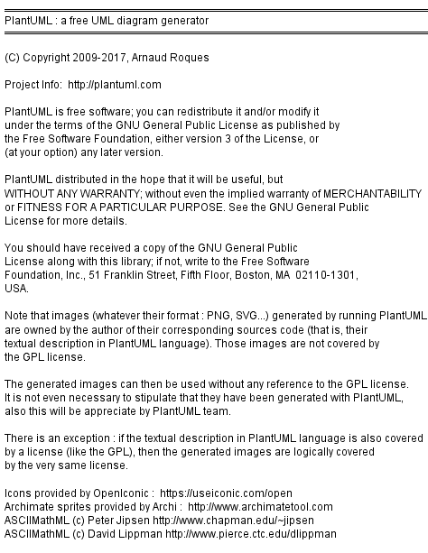

## Authors

@startuml

authors

@enduml



## VBA code Shellandwait

' By Chip Pearson, chip@cpearson.com, www.cpearson.com

' This page on the web site: www.cpearson.com/Excel/ShellAndWait.aspx

' 9-September-2008

(Public domain)

## VBA Registry code

Based on macro’s published on <http://www.slipstick.com/developer/read-and-change-a-registry-key-using-vba/>

# Examples

See [http://plantuml.sourceforge.net](http://plantuml.sourceforge.net/) for more information and examples

## Basic sequence diagram

@startuml

title <u>Simple</u> communication example\non several lines

Alice -> Bob: Authentication Request

Bob -> Alice: Authentication Response

@enduml

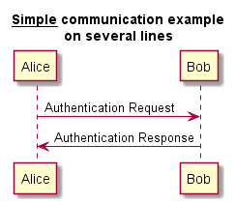

## Class example

@startuml

skinparam classAttributeIconSize 0

class Dummy {

-field1

#field2

~method1()

+method2()

}

@enduml

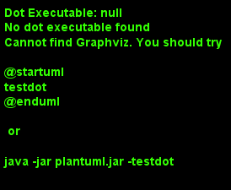

## Activity (parallel)

@startuml

start

if (multiprocessor?) then (yes)

fork

:Treatment 1;

fork again

:Treatment 2;

end fork

else (monoproc)

:Treatment 1;

:Treatment 2;

endif

@enduml

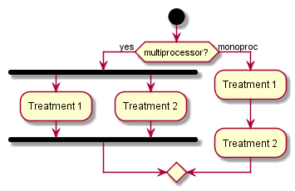

## Components (and @rescale)

@startuml

'@rescale 0.7

package "Some Group" {

HTTP - [First Component]

[Another Component]

}

node "Other Groups" {

FTP - [Second Component]

[First Component] --> FTP

}

cloud {

[Example 1]

}

database "MySql" {

folder "This is my folder" {

[Folder 3]

}

frame "Foo" {

[Frame 4]

}

}

@enduml

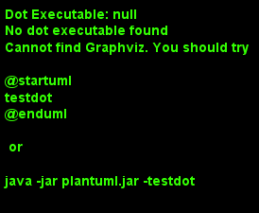

## Statechart

@startuml

scale 350 width

[*] --> NotShooting

state NotShooting {

[*] --> Idle

Idle --> Configuring : EvConfig

Configuring --> Idle : EvConfig

}

state Configuring {

[*] --> NewValueSelection

NewValueSelection --> NewValuePreview : EvNewValue

NewValuePreview --> NewValueSelection : EvNewValueRejected

NewValuePreview --> NewValueSelection : EvNewValueSaved

state NewValuePreview {

State1 -> State2

}

}

@enduml

